Topic: Hands-on practice of signals and their properties in Scilab

* **Pure Signal**

A signal is said to be pure when it is made of only one function. The function can be anything for example for sinusoidal wave, the function would be sine or cosine depending upon the value at time t=0.

* **Composite Signal**

A signal consists of different types of function and summation or multiplication of those function, it is known as a composite signal. For example, sin(2x) + cos(3x) is composite signal.

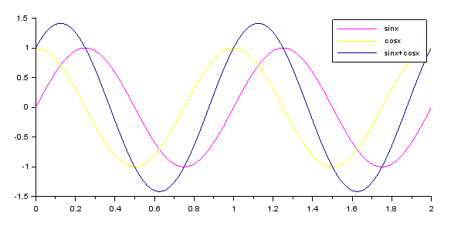

* sinx & cosx both are pure signals.
* sinx+cosx is a composite signal.
* What happens to a signal when we change the Amplitude, Phase, Frequency of Pure and Composite signals?

1. Changing Amplitude:

If we change the amplitude of our signal (i.e. we increase the scaler multiplied to our basic function) the peak of the wave will be increased both the positive and negative side. But as the frequency is constant for both the signals, the wave will hit x-axis at the same time as of earlier wave.

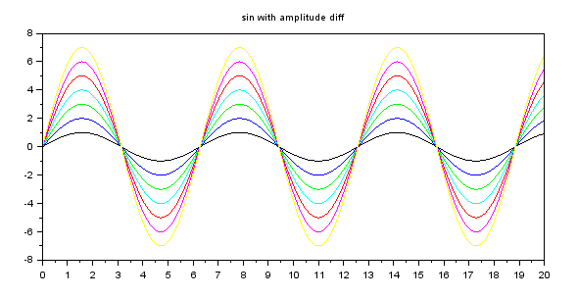

1. Changing Phase:

Changing the phase of the signal means shifting our wave right or left to some extent depending upon what Phase difference is required. A simpler way to look at it is “cosine wave is having 90 degrees of phase with respect to sine wave.”

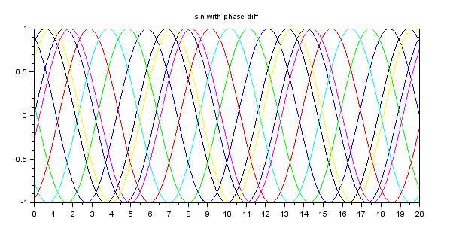

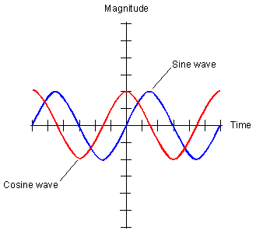

1. Changing frequency:

As we change the frequency, the time period will change accordingly as well as wavelength. If we increase the frequency, the wave will have more number of cycles per second as the definition suggest. It’ll make our wave go for more number of transitions from positive to negative & vice versa.

